Section 23: More Solution Architectures

AWS Solution Architect Associate

# 267. Event Processing in AWS

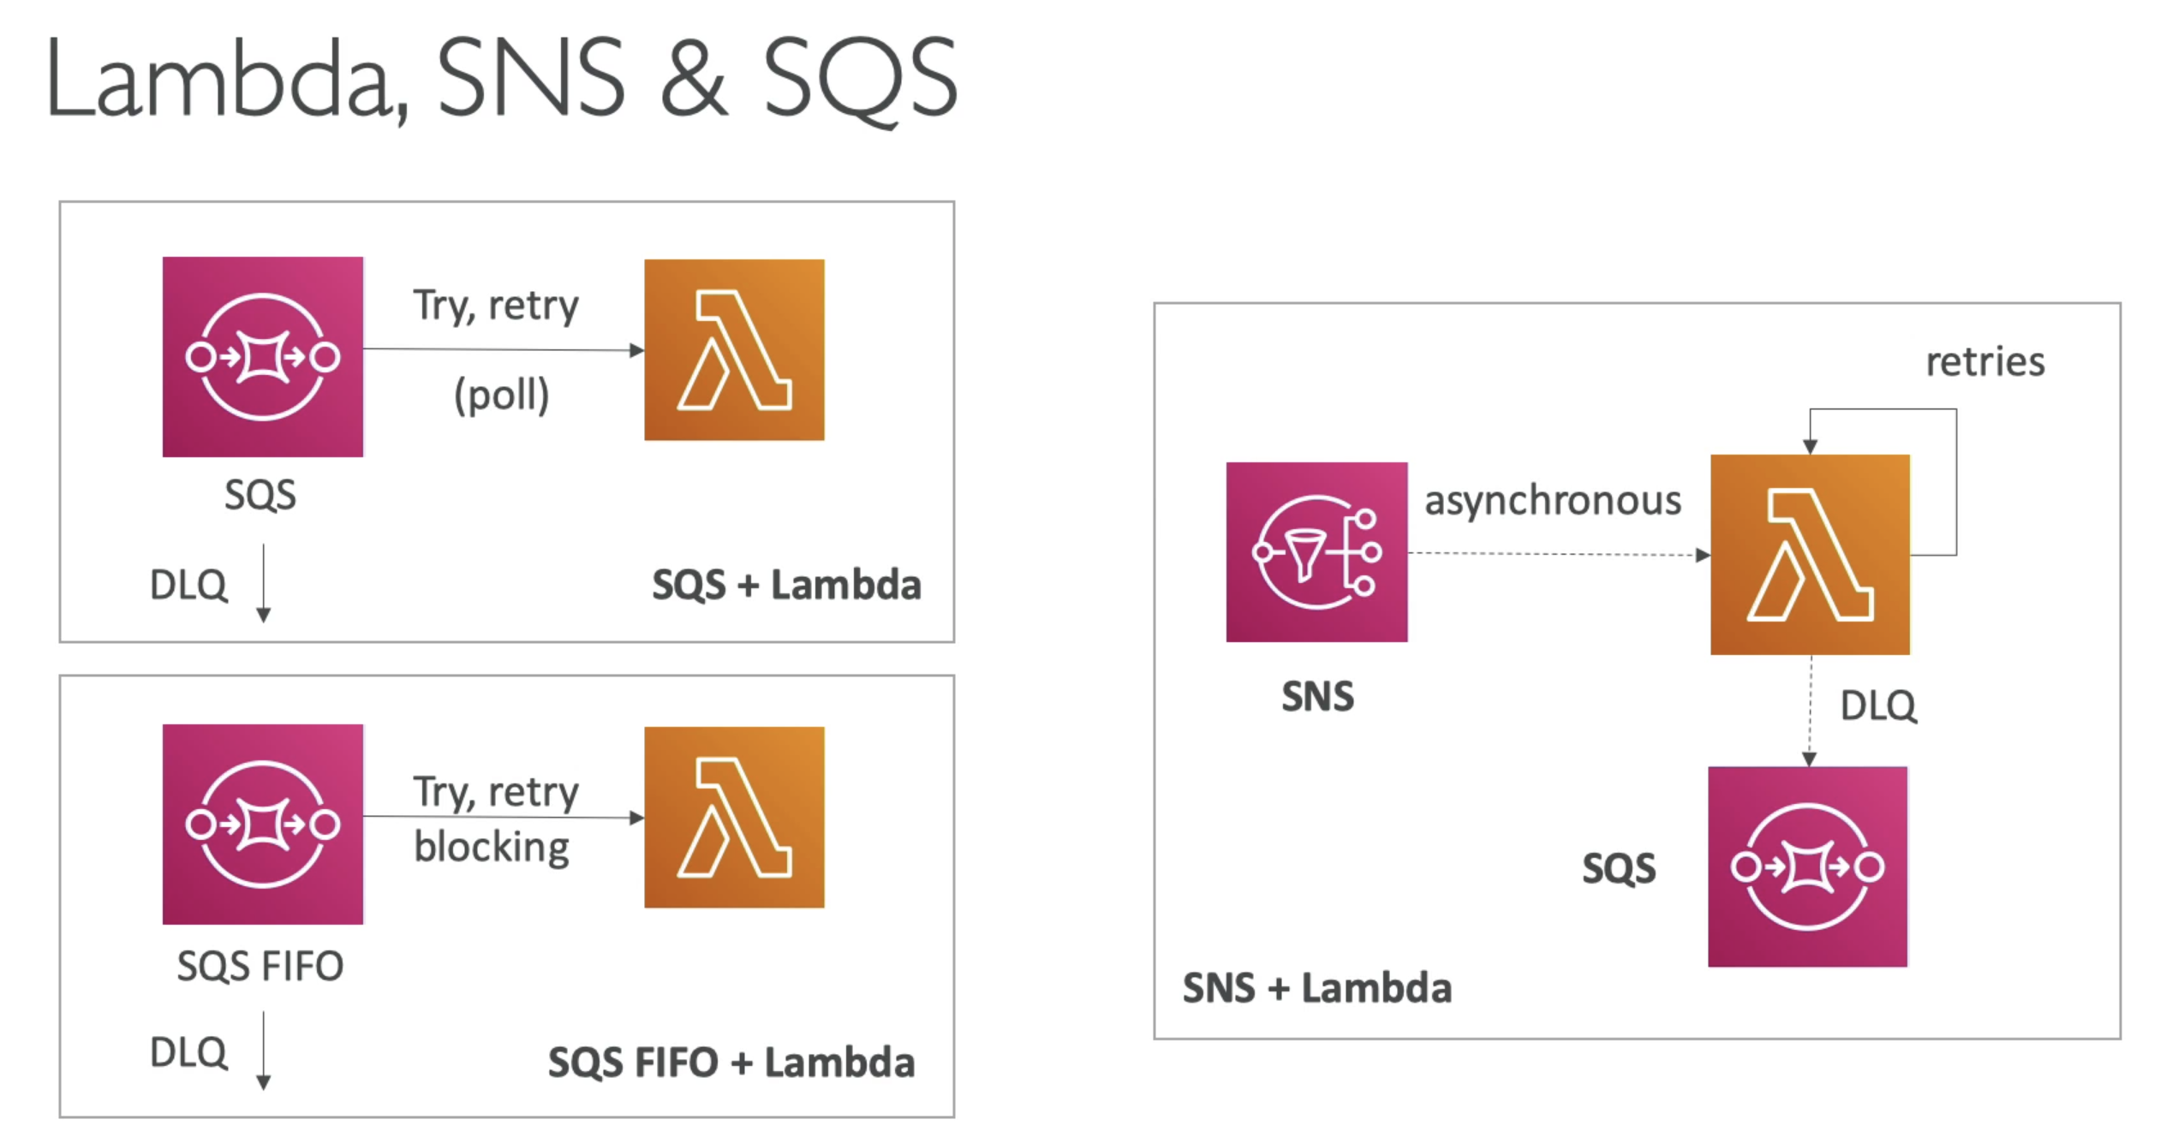

## Fan Out Pattern

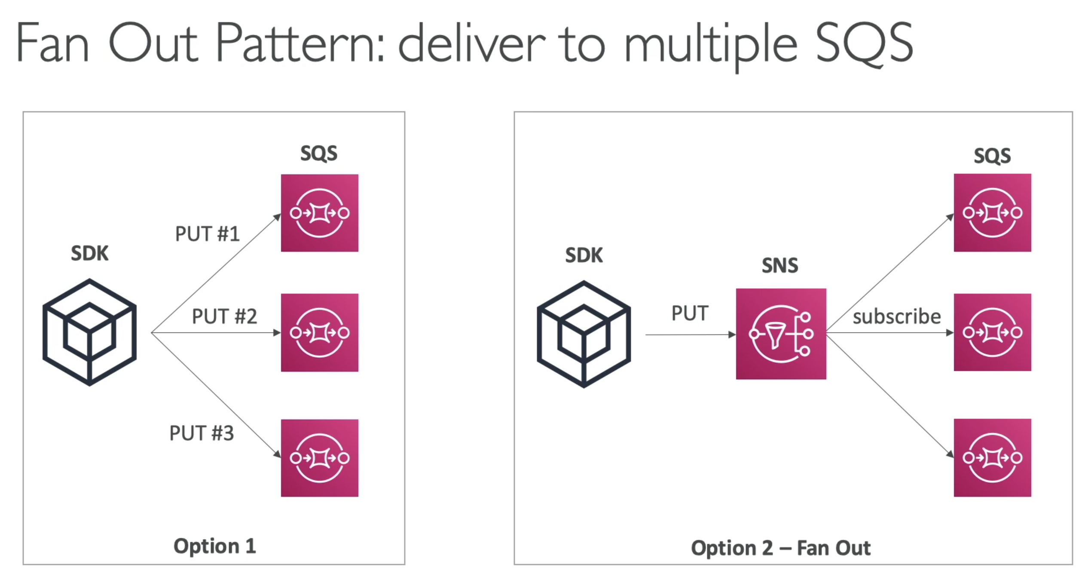

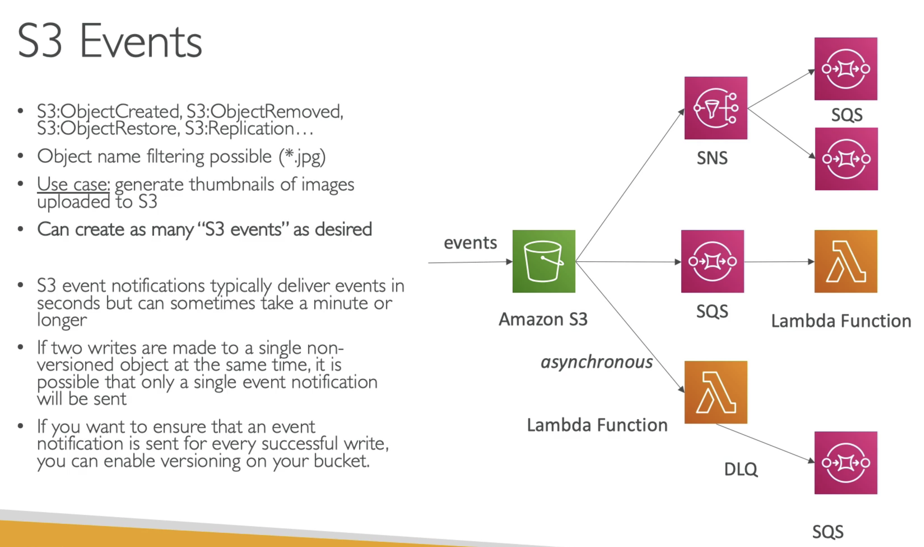

# 268. Caching Strategies in AWS

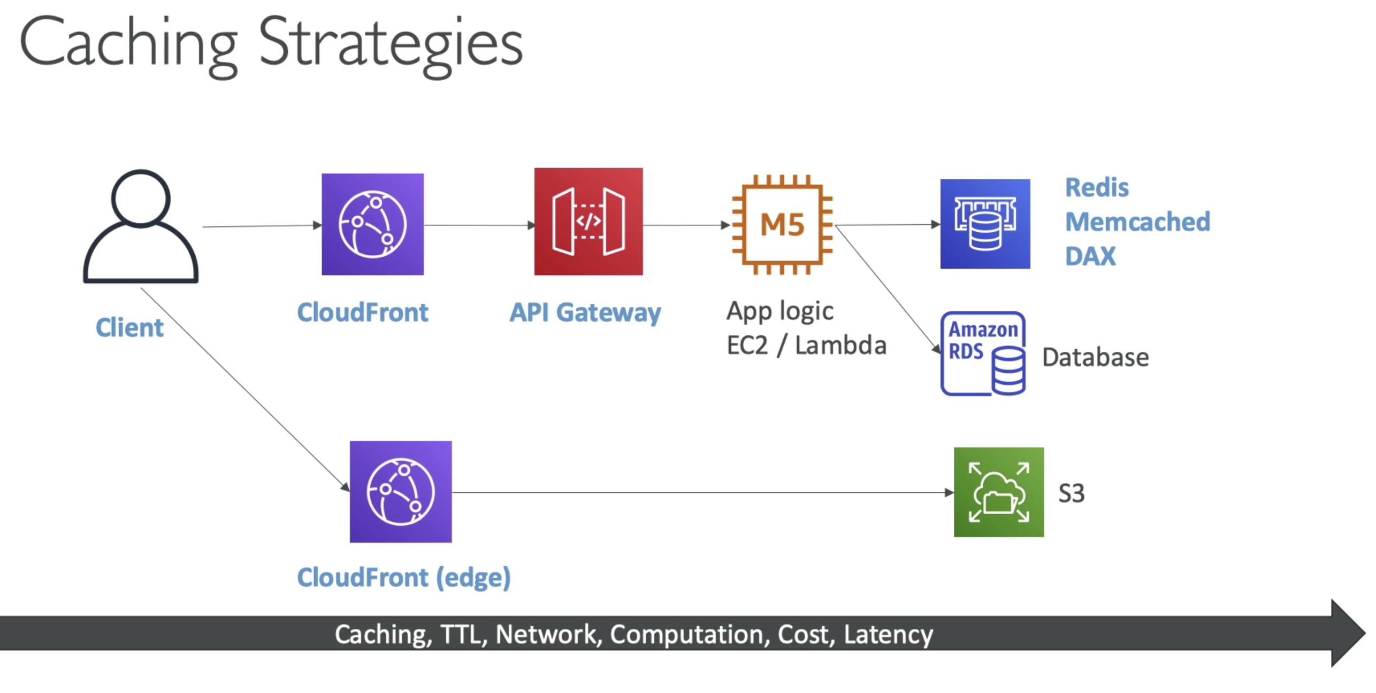

# 269. Blocking in IP address in AWS

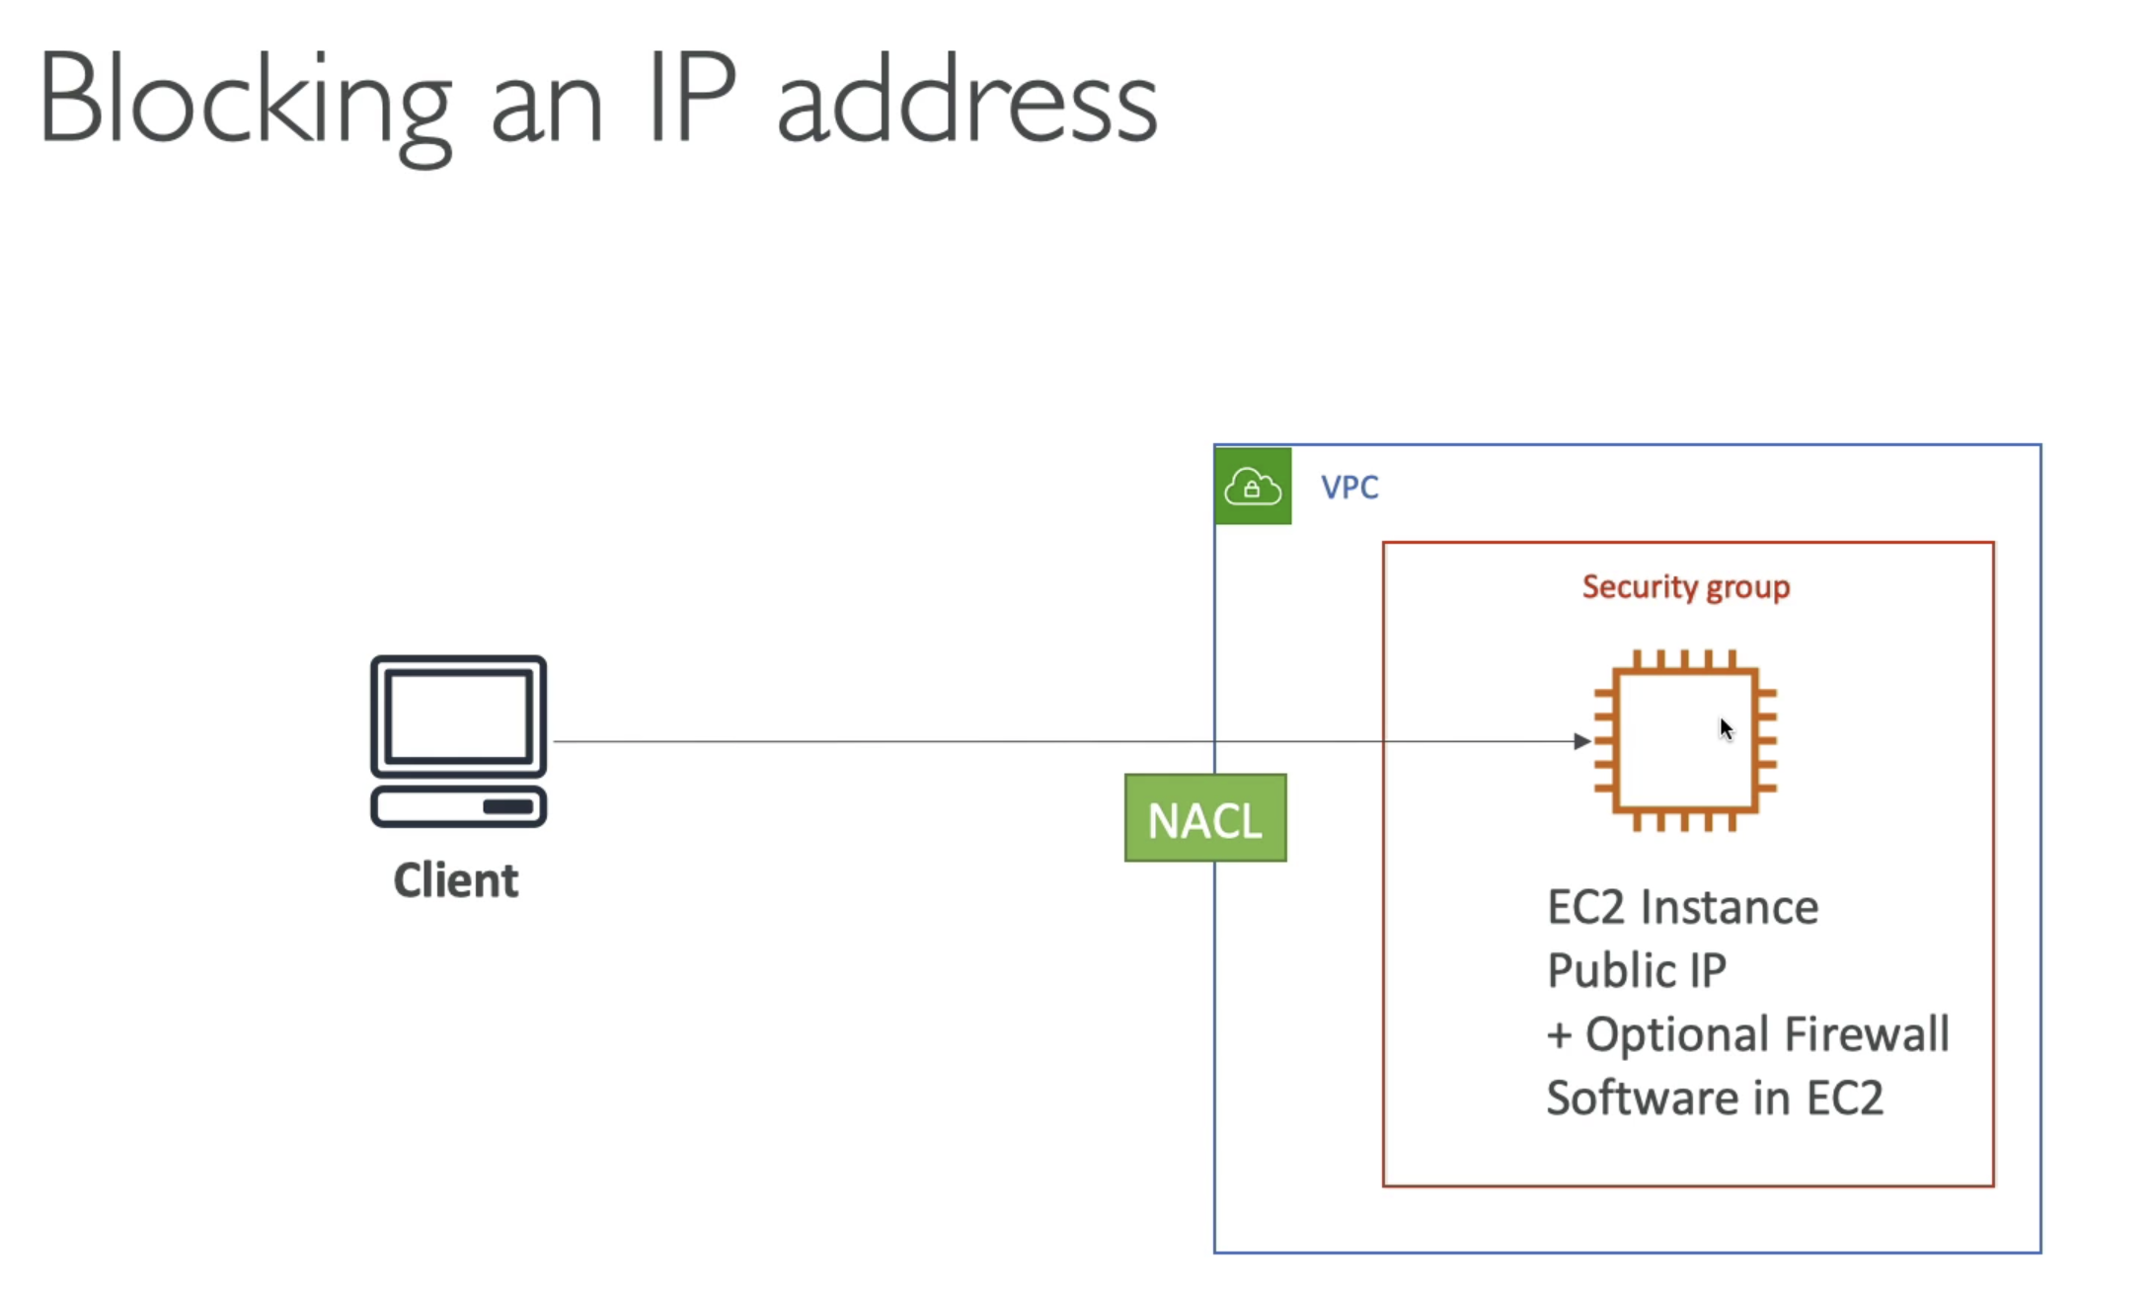

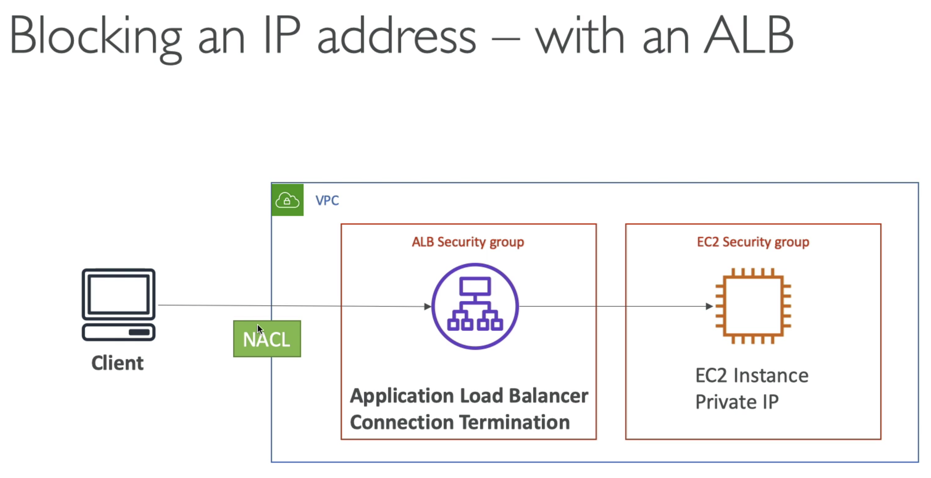

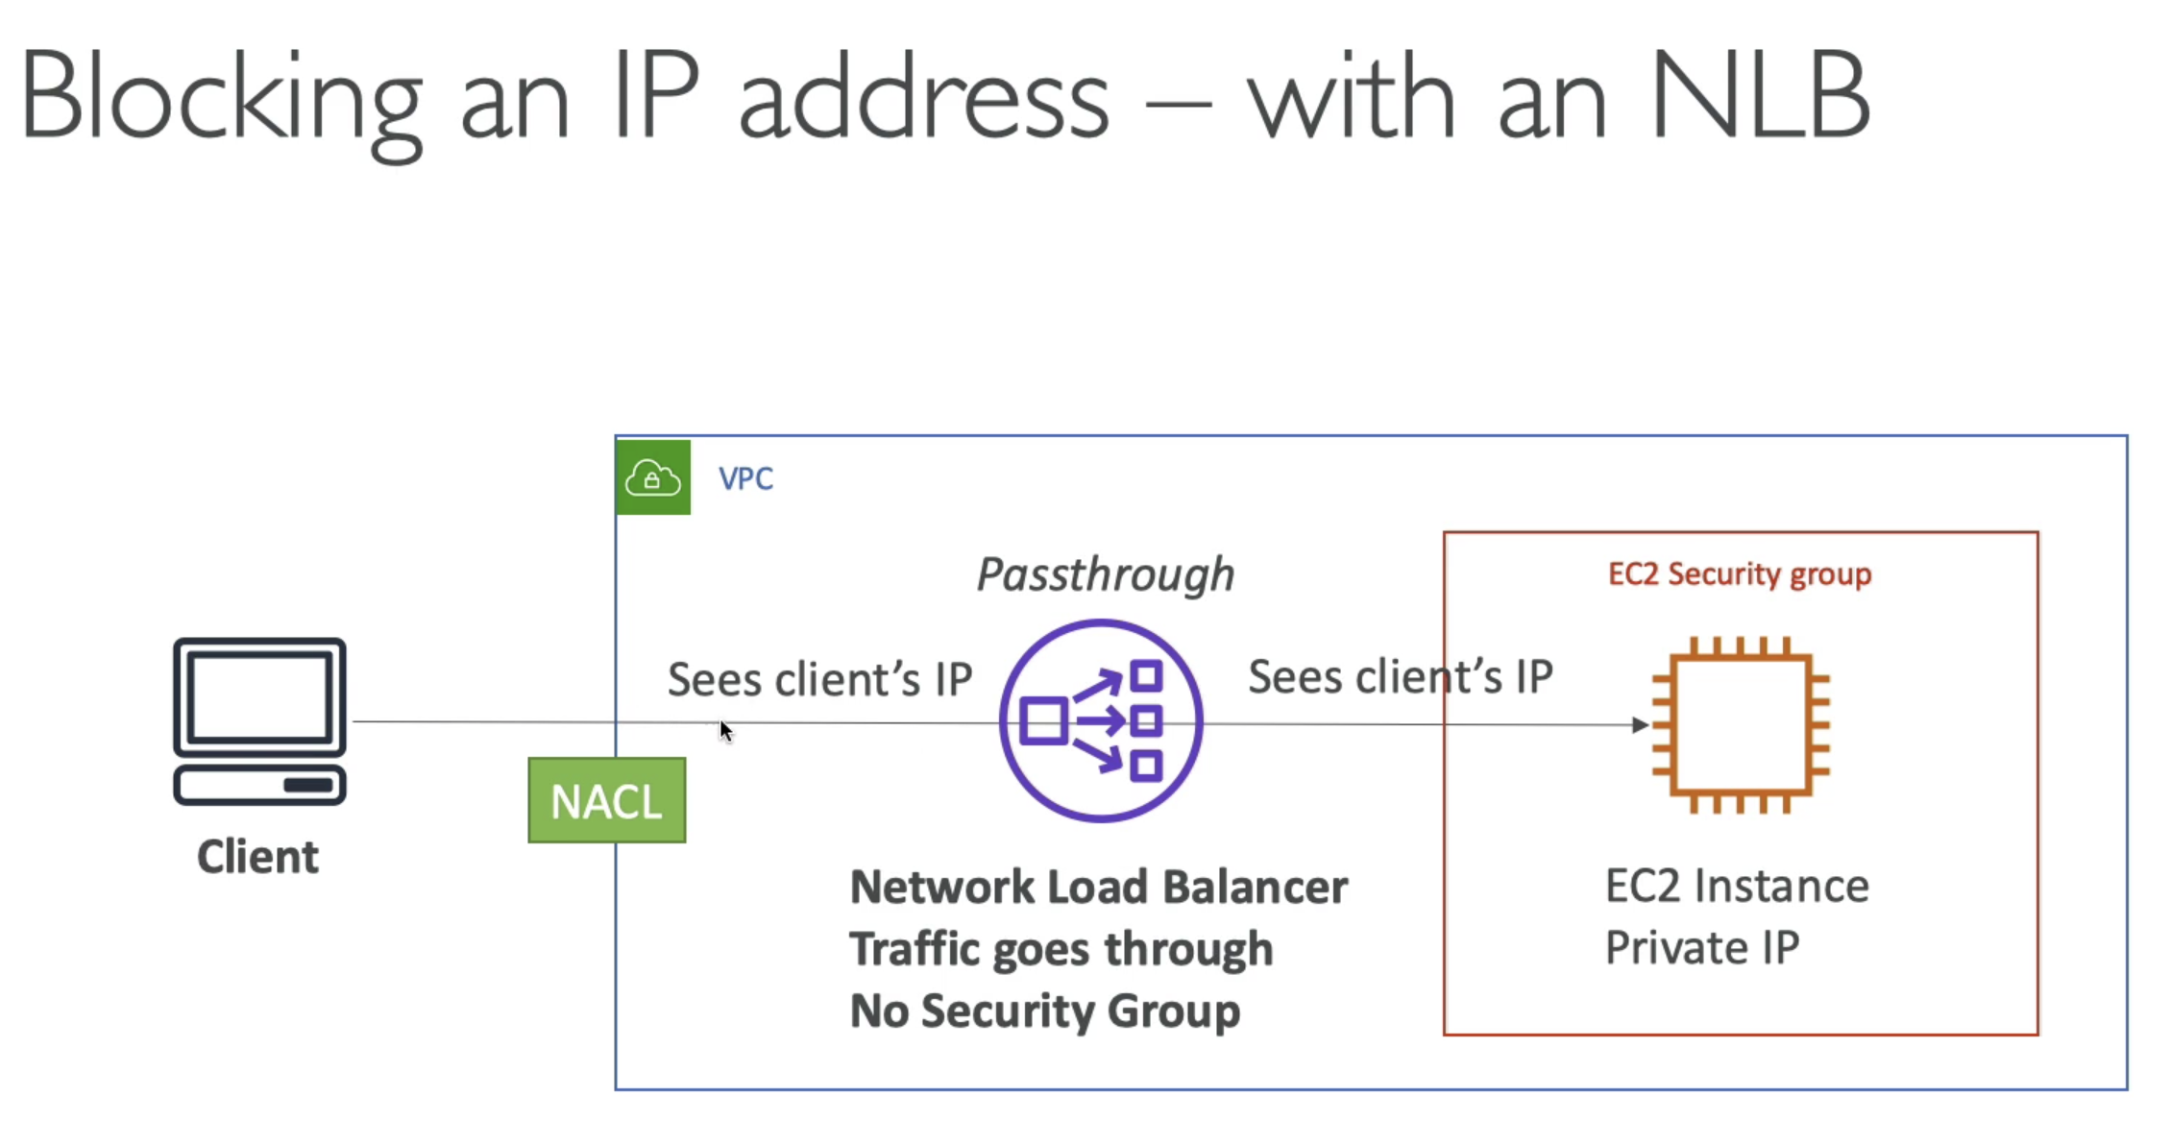

* NLB does not have a security group, all the traffic passes through the NLB, and directly hit the EC2 client….
* The only place to block an IP is the NACL

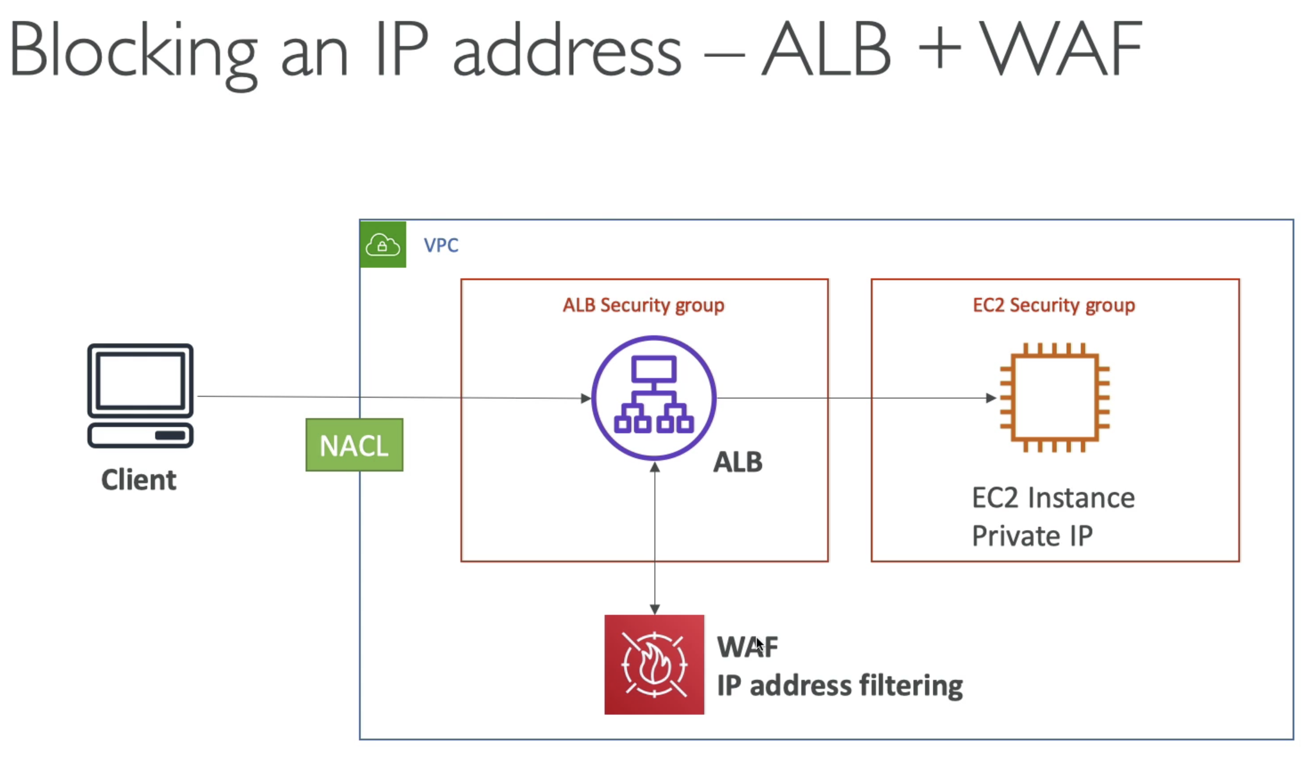

* WAF is installed on ALB, where we can define a bunch on rules. So it is one more line of defence.

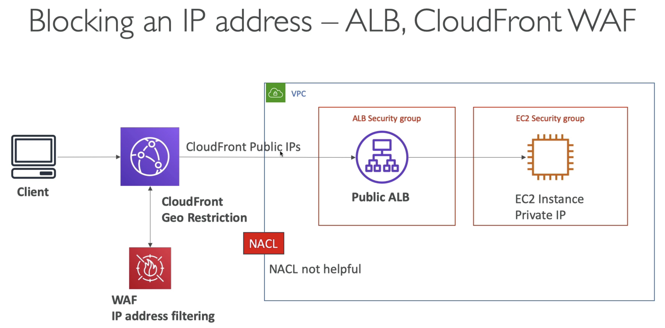

* CloudFront sits outside of VPC
* ALB does not see the client IP, rather it will see all the CloudFront Public IP’s… SO NACL will not see any client IP, hence cannot block them
* CloudFront Geo Restriction
  + If we are attacked by a country
* If there is one annoying IP, which we want to block
  + User WAF at CloudFront level

# 270. High Performance Computing in AWS

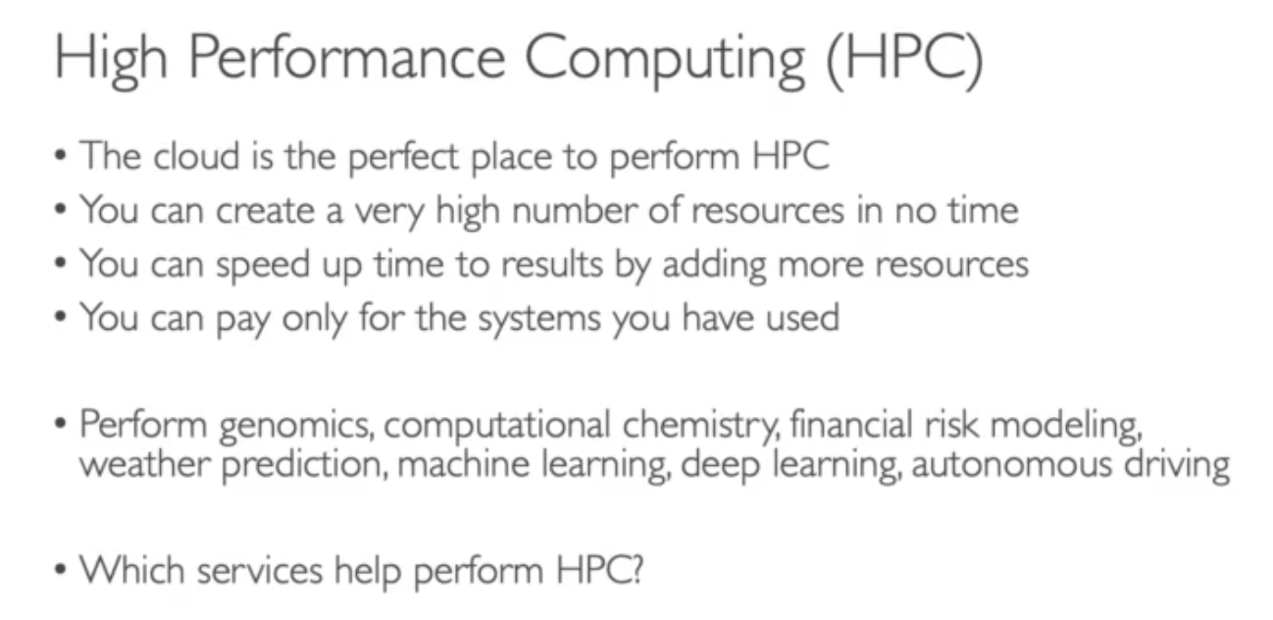

## Data Management & Transfer

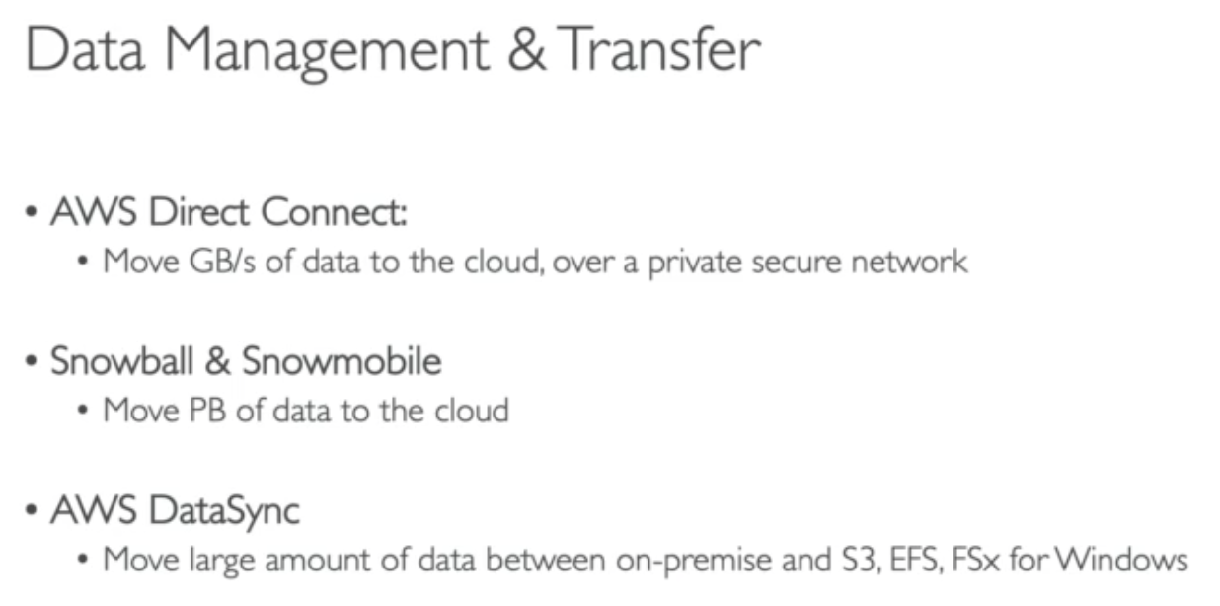

## Compute and Networking

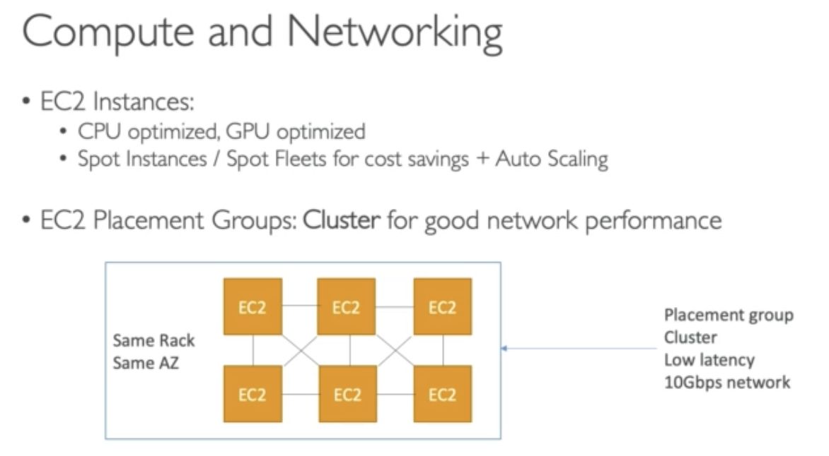

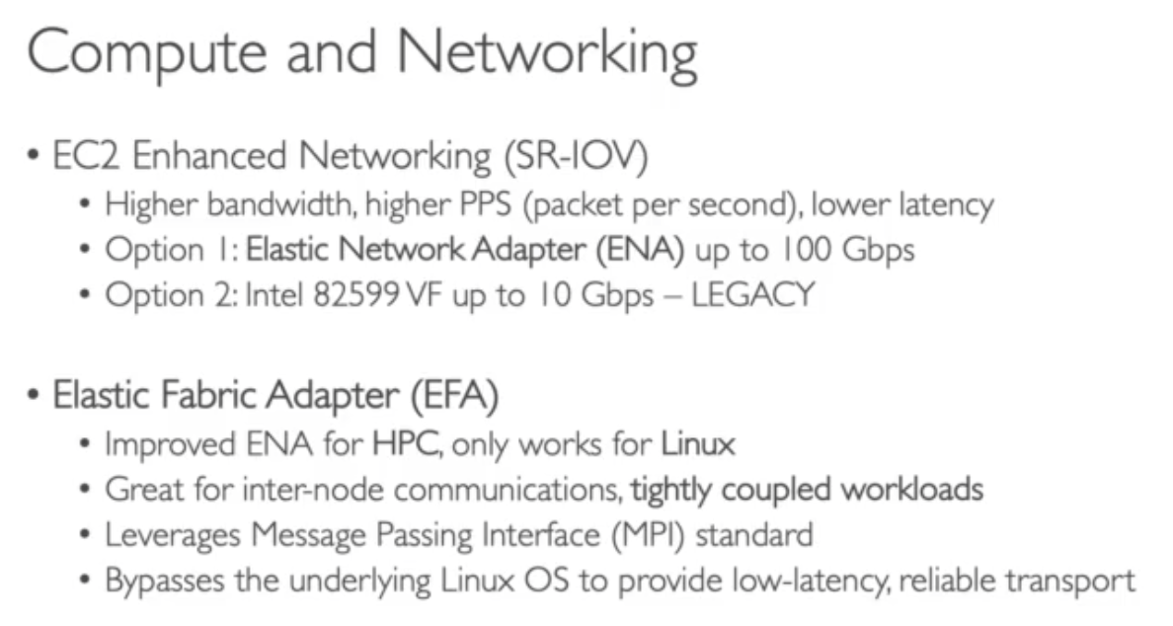

## Storage

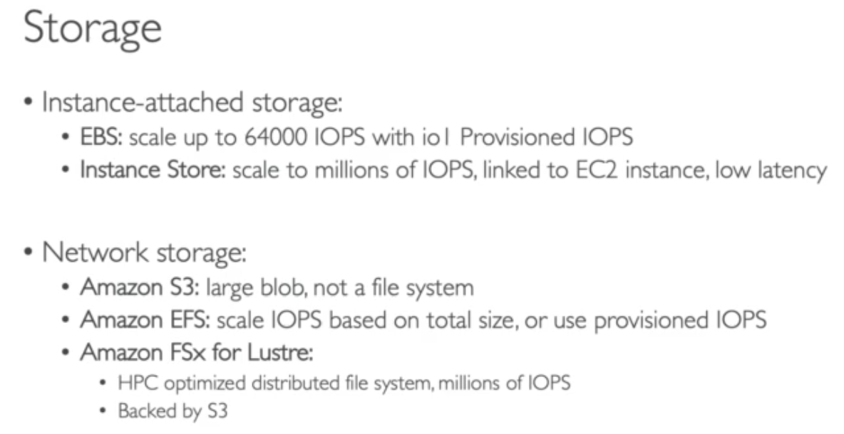

## Automation & Orchestration

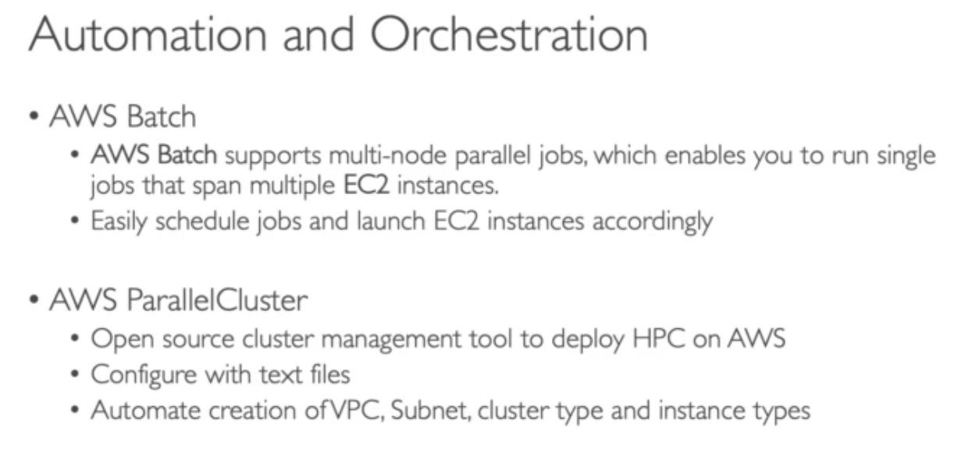

# 271. EC2 Instance availability

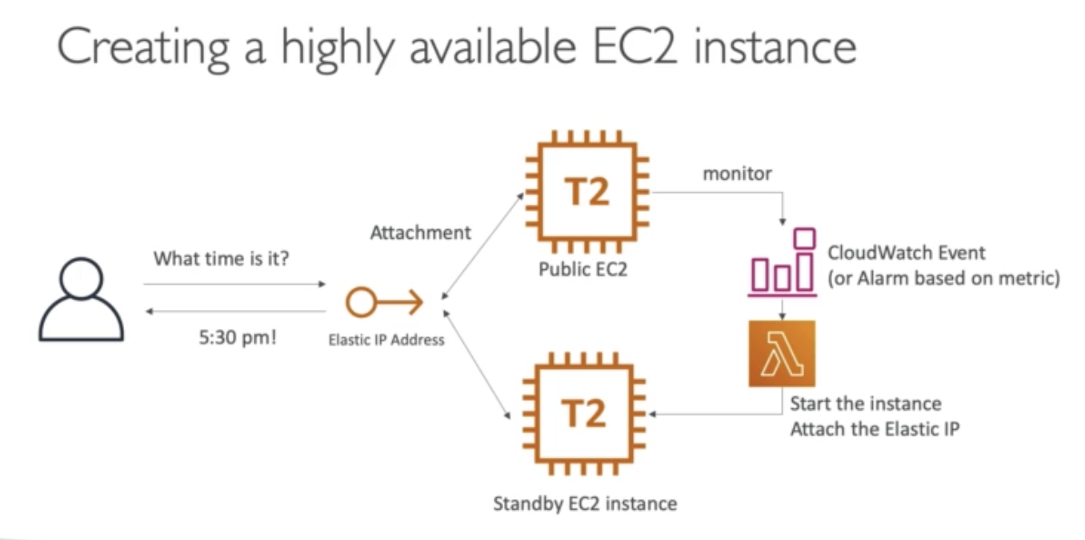

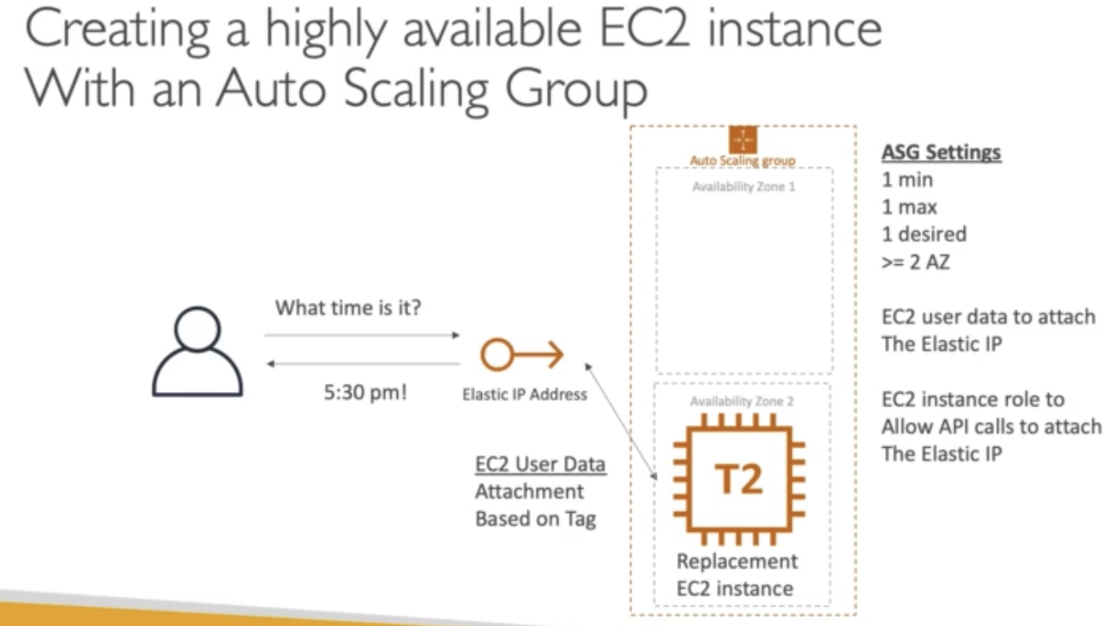

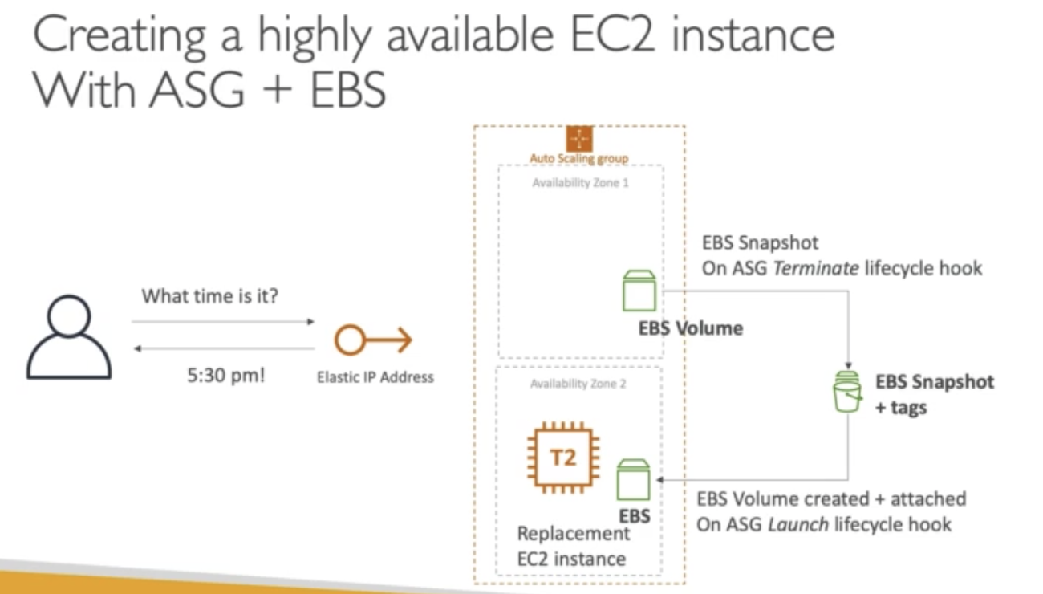

## 272. Bastion Host High Availability

The whole idea of Bastion Host is that – we want to be able to SSH into the EC2 instance in the private subnet from the client, which in on a public internet.

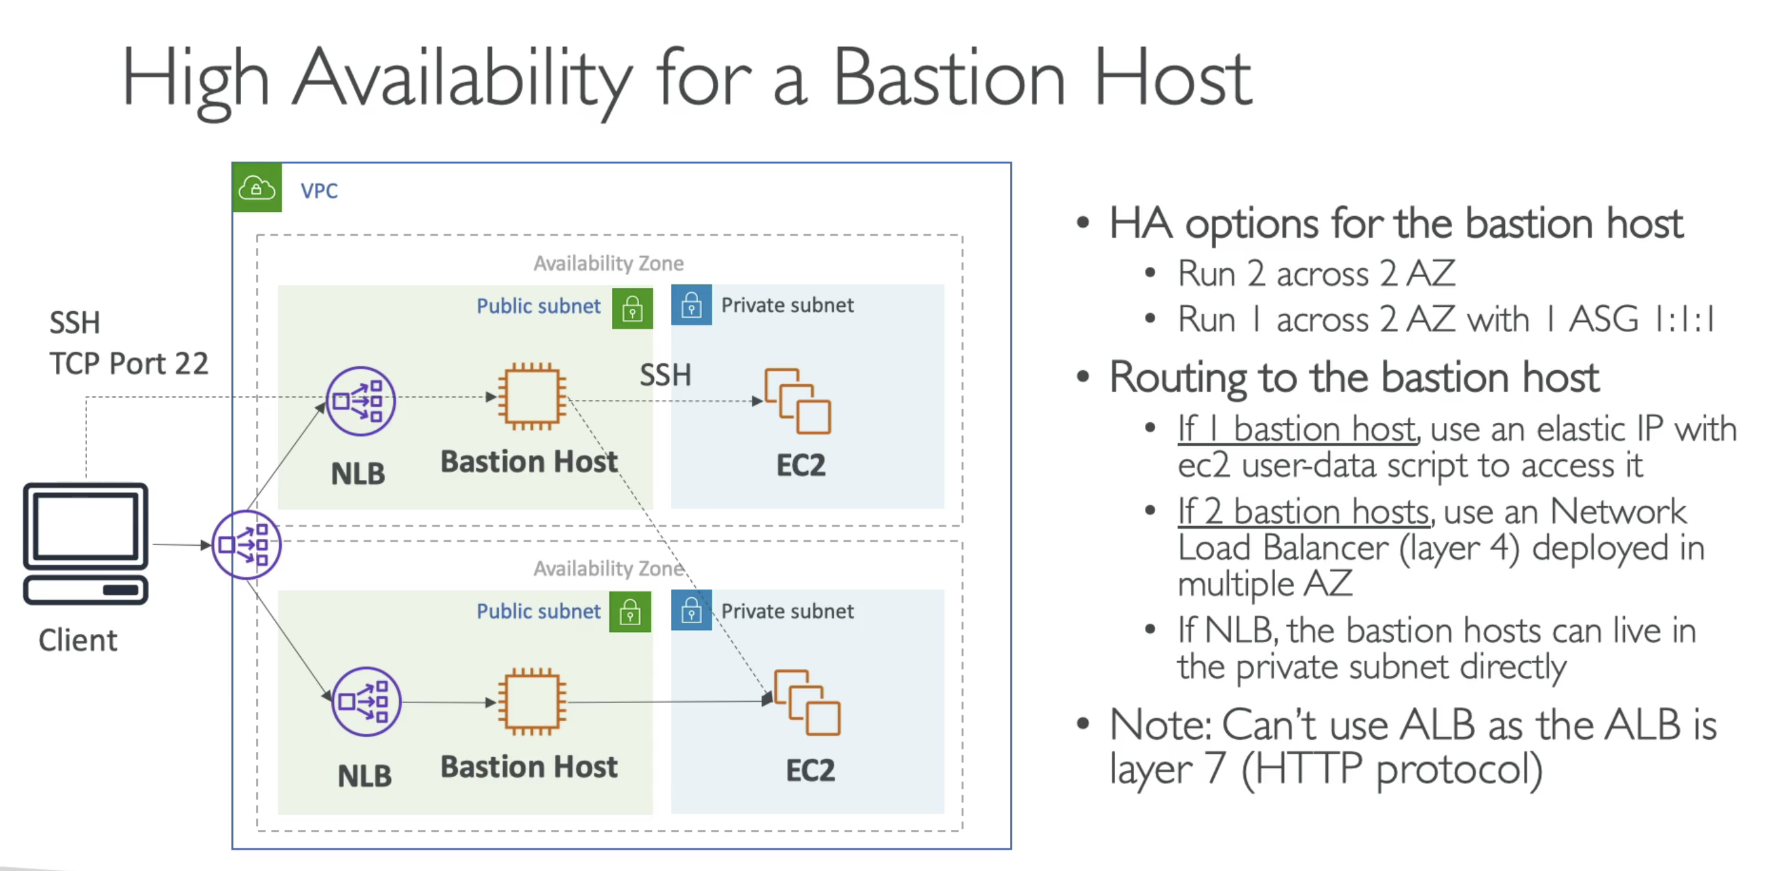

* SSH protocol required layer4, because it uses TCP protocol only. So we cannot use ALB with Bastion hosts

# Quiz

